**Chocolate and coconut-flour covered cubes**

Sponge ingredients:

3 eggs

5 table spoons of granulated sugar (220 g)

13 table spoons of oil ( 180 millilitres)

16 table spoons of flour ( 300 g )

100 millilitres of milk

1 raising agent

1 lemon zest

Cream ingredients:

250 g of margarine

100 g of cooking chocolate

1 table spoon of rum

200 millilitres of milk

Method of preparation:

Make a sponge using the mentioned ingredients. Put egg whites and egg yolks in two separate bowls. Whisk egg whites with sugar until firm and then add oil,6 spoons of flour and raising agent,one by one egg yolk,milk,lemon zest and remaining flour. Pour it in a medium-sized mould ( 25 × 35 cm ) covered with baking paper. Bake it at 180 degrees until the

sponge starts removing from the sides of the mould.

Melt margarine and chocolate and add sugar,milk and rum in the end. When the mixture starts boiling,remove it from the heat.

Cut the sponge into cubes and then dip each cube into warm cream and roll it in coconut flour.

**Čupavci**

Biskvit:

1. [jaja](https://www.coolinarika.com/namirnica/jaja/)
2. jušnih žlica kristal šećera
3. jušnih žlica ulja (180 ml)
4. ušnih žlica brašna (300 g)

100 ml [mlijeka](https://www.coolinarika.com/namirnica/mlijeko/)

1 [prašak za pecivo](https://www.coolinarika.com/namirnica/prasak-za-pecivo/)

1 korica limuna

Krema:

* 250 g [margarina](https://www.coolinarika.com/namirnica/margarin/)
* 100 g [čokolade za kuhanje](https://www.coolinarika.com/namirnica/cokolada-za-kuhanje/)
* 1 veću žlicu [ruma](https://www.coolinarika.com/namirnica/rum/)
* 200 ml [mlijeka](https://www.coolinarika.com/namirnica/mlijeko/)

*Priprema:*

Od navedenih sastojaka pripremiti biskvitno tijesto: u posudu za miksanje stavimo bjelanjke, a žumanjce odvojiti u jednu čašu. Miksati bjelanjke sa šećerom u čvrst snijeg, pa dodavati i miksati redom: ulje, 6 žlica brašna i prašak za pecivo, jedan po jedan žumanjak, pa mlijeko, korice limuna i preostalo brašno. Ulijemo u kalup srednje veličine (cca 25×35 cm) u koju smo stavili papir za pečenje.

Pečemo na 180℃ dok se biskvit počne odvajati od stranica kalupa.

Punč kremu skuhati na način da se prvo stavi otopiti margarin i čokolada, kad je otopljeno, dodati šećer, pa mlijeko i na kraju rum. Kad krema zakuha maknuti s vatre.

Biskvit odrezati na [kockice](https://www.coolinarika.com/slika/229839) pa svaku umakati u toplu kremu i uvaljati u kokosovo brašno.

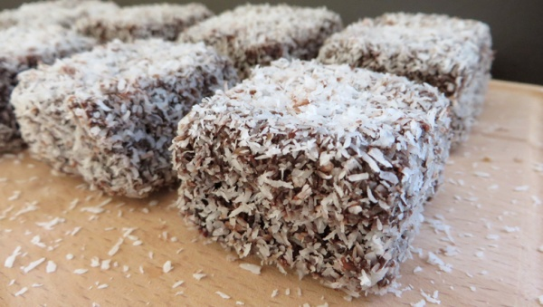

**Drunk little balls**

Ingredients:

100 g of butter

100 g of caster sugar

200 g of lady fingers

A bit of cherry brandy

30 cherries from cherry brandy

100 g of cooking chocolate for the icing (if you wish )

Method of preparation:

Crumble lady fingers and sprinkle them with cherry brandy. Add caster sugar to it. Melt chocolate and butter over low heat, mix it in lady fingers and mix it until you get a uniform mixture. Put it in the refrigerator to cool.

Using cooled mixture, form small balls and press a stoned cherry into each. Arrange them on a baking tray and pour it with melted chocolate if you wish.

**Pijane kuglice**

SASTOJCI:

* 100 g tamne čokolade
* 100g maslaca
* 100g šećera u parahu
* 200g piškota
* Malo višnjevače
* 30 višanja iz likera
* Po želji 100g čokolade za glazuru

PRIPREMA:

Piškote grubo izmrvite, pa ih dobro nakapajte s višnjevačom. U to dodajte šećer u prahu. Na laganoj vatri istopite maslac i čokoladu, pomiješajte u piškote i miješajte dok ne postane jednolična smjesa. Stavite u hladnjak hladiti.

Od ohlađene smjese pravite kuglice i u svaku od njih utisnite višnju. Staviti ih na lim i po želji preliti čokoladnom glazurom.

