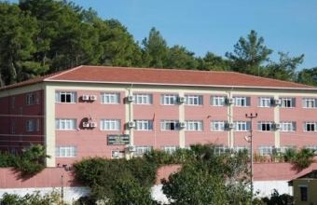
My name is Elif Kaplan. I am thirteen years old. My father's name is Ali Murat. My mother's name is Güler. I have a brother and we are two siblings. He's name is Orhan. My mother is housewife and my father is chef in hotel
I like playing volleyball,swimming reading books. I don’t have a fear
I want to be psychologist so I should go a good high school. I want to be psychologist because I like solving problems.
I am student of Berat Hayriye Cömertoğlu Secondary School in Okurcalar. I am 8th grade.
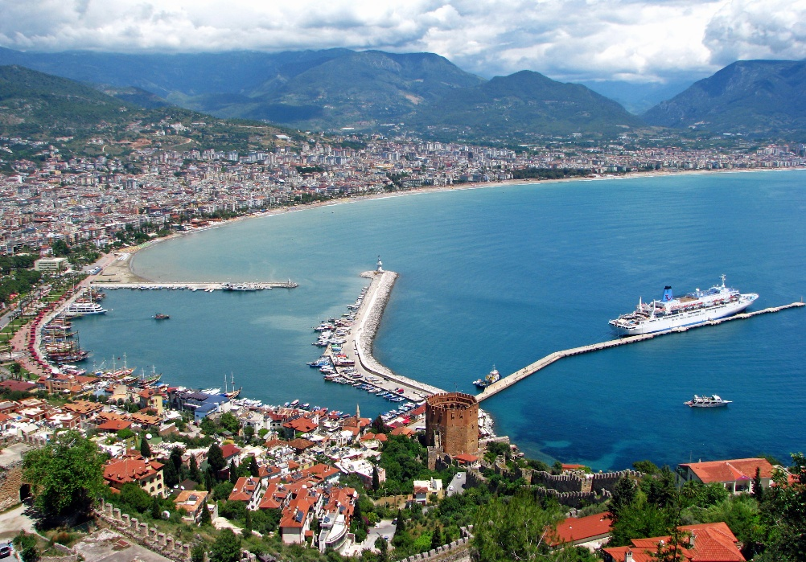
I live in Okurcalar and here is touristic place. People making a live with tourism here. There are many places to visit such as but not limited to Alanya Castle, Red Tower...

