My Hobbıe
My Story
Hi

My name is Sercan, my surname is Tahiroğlu, I am a student, my father's name is Feysel, my mother's name is Nezihe.

2020

My Hobbıes
My hobby is repairing broken computers I take care of them and I play games with some kind of coding

My Phobias

the things I fear are snakes and reptiles I'm afraid of them and I don't like them because they're so scary

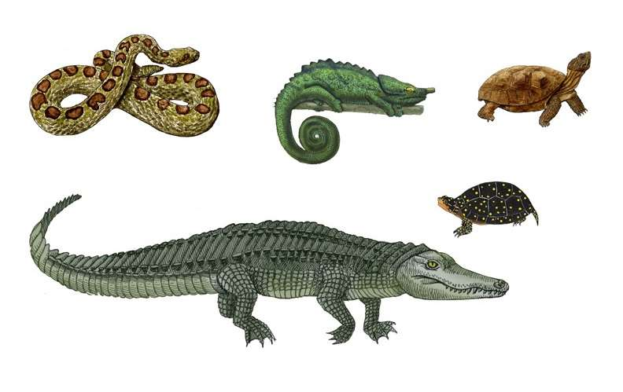
My School
here is my school i love my school because there my friends and teachers are there and i play with my friends during break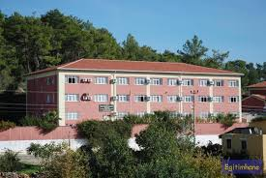

SEE YOU