AUTOBİOGRAPHY
Hello my name ıs Ahmet surname, Korkmaz, I am 13 years old, I am sitting in Alanya
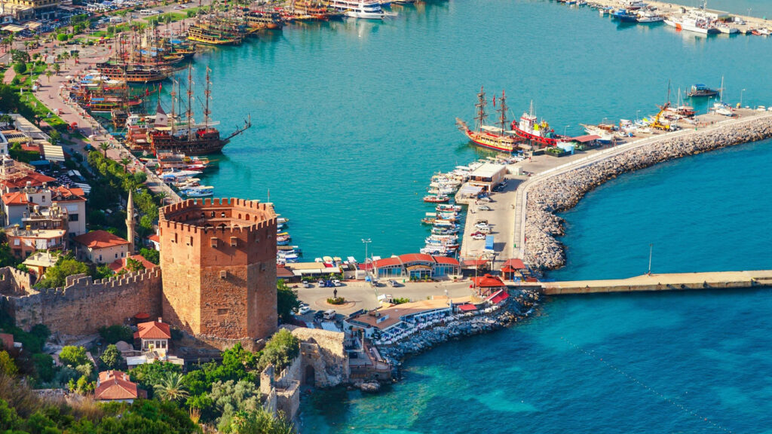

MY HOBBIES
Running

Cycling
MY PHOBİES

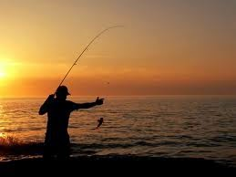
Fishing

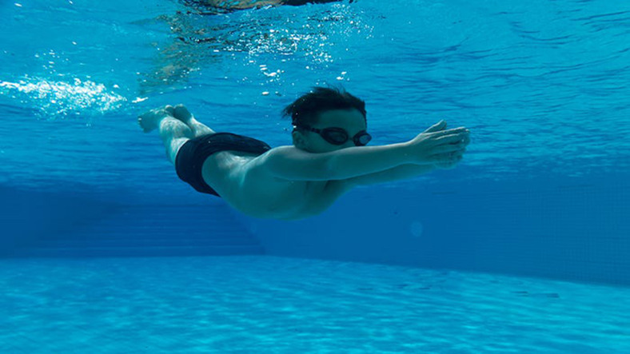
Swimming
I’m studying 8th grade at Okurcalar Berat Hayriye Cömertoğlu Secondary School

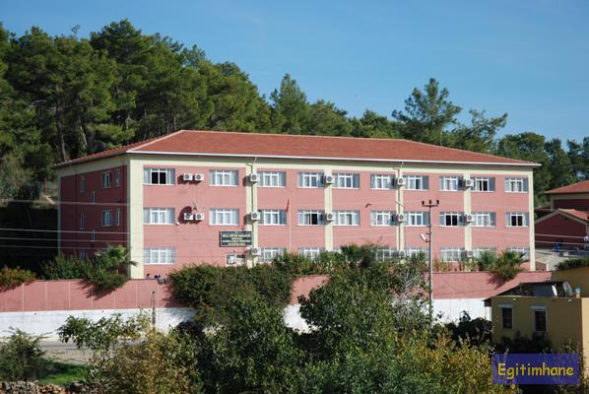
I wish you happiness

